Job Description
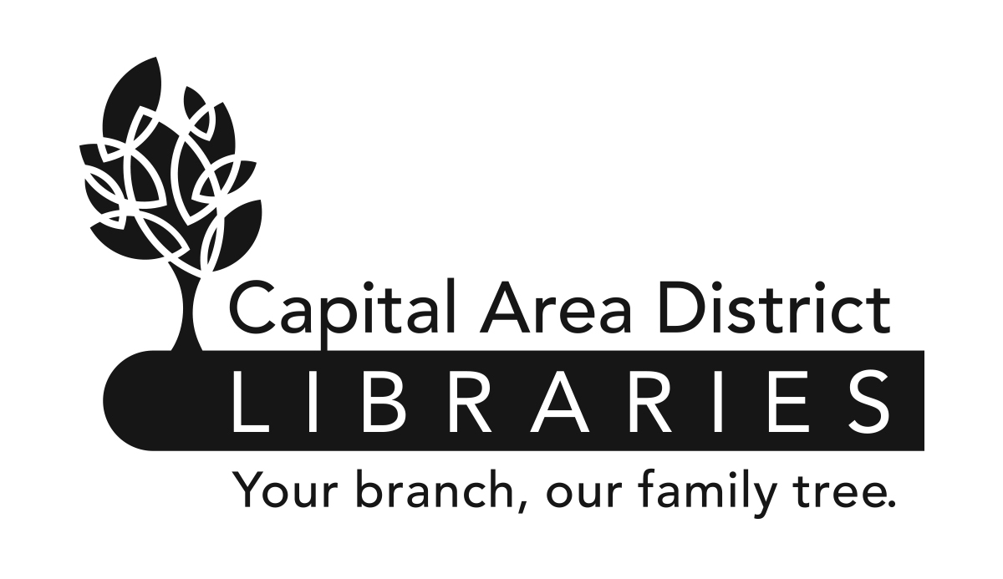

Position: | Library Assistant
Range: | T4 (Non-Exempt) (Union)
Reports to: | Branch Head or Public Services Head
Supervises: | None
Reviewed:
Revised:

www.cadl.org

Job Summary

Under the supervision of a Library Head or Public Services Head, provides excellent, friendly and user centered services to community members. Assists patrons in basic technology support and troubleshooting of digital services and resources. Assists at the customer service desks. Plans and organizes library events both inside and outside of the library.
Duties and Responsibilities

- Provides excellent, friendly, and user centered service that welcomes all community members seeking library services. Builds relationships through inclusive communication and showing a sense of fairness and goodwill.

- Instructs and assists patrons in basic technology support and troubleshooting of digital services and resources.

- Assists at the circulation, information, and children’s public services points. Assists patrons in library and on the phone answering questions about collections, library services, digital resources, and policies. Helps patrons with general informational questions and locating resources. May perform circulation duties including checking out library items to patrons, assisting patrons with membership accounts, collecting fees, and issuing library cards.

- Plans and presents library programs for the community. Coordinates scheduling of assigned programs and/or activities, gathers materials and establishes and follows budget.

- Staffs outreach events, providing access to library services and information outside the library building, including at schools, fairs, and outdoor markets."

- Provides assistance to patrons by suggesting titles based on their interests. Recommends library services, events, and items available to patrons. Uses book recommendation tools and writes reviews of library materials for the CADL website.

- May process interlibrary loan requests from community members. Checks in materials and prepares returning and outgoing materials.

- Prepares attractive and eye-catching displays, exhibits and bulletin boards featuring library materials and/or services and community information. Maintains an informative and attractive physical setting in the branch.

- May update and replace periodicals such as daily newspapers and weekly and monthly magazines.

- May carry out collection maintenance responsibilities including monitoring assigned portions of the collection (books, DVDs, Blu-rays, CDs and books on CD) and removing items that don’t meet standards and suggesting titles for replacement or addition to the branch’s collections.

- Completes required training elements and may attend workshops, webinars, seminars appropriate to their position.

- May act as the person in charge of the branch filling in during the Head Librarian’s or Public Service Head’s absence following well-defined policies and procedures. Consults with the Executive Director on major issues in the absence of the Head Librarian.

- In the absence of the Head Librarian or Supervisor, may supervise the work of library clerks and pages.

- Assists in shelving library materials and maintaining library facilities as needed.

The above statements are intended to describe the general nature and level of work being performed by people assigned this classification. They are not to be construed as an exhaustive list of all job duties performed by personnel so classified.

Job Requirements
- Possession of a bachelor’s degree or its equivalent.

- This is an entry-level classification; no specific prior experience is required. Experience working in a public library is preferred.

- Successful completion of a six-month probationary period.

- Be physically able to perform the essential functions of the job with or without reasonable accommodation.

- Second Language speakers desired.

- Ability to use technology devices to access databases and information sources.

- Effective oral and written communication skills.

- Ability to supervise, direct, and organize the work activities of others.

- Ability to establish and maintain effective working relationships with co-workers, community organizations and the public.

- Ability to conduct oneself with tact and courtesy.

Library Assistant Job Description
Page 2 of 2

